SELECT LPAD(<table_name>,8,'x') from <table_name>;  
SELECT RPAD(<table_name>,8,'x') from <table_name>;

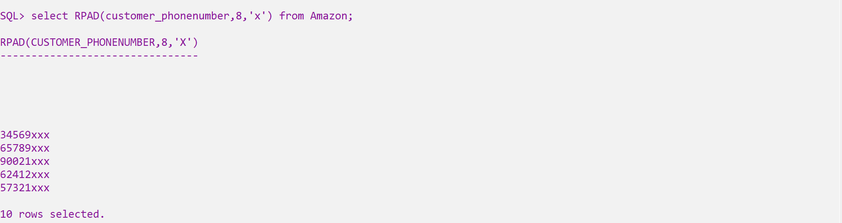  
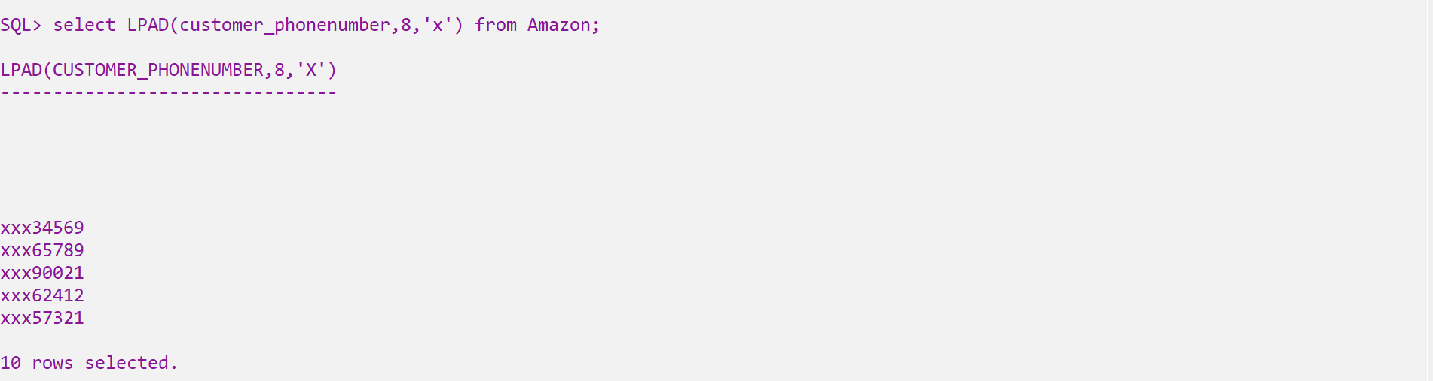

Select TRIM(<letters> from <string>) from <table_name>

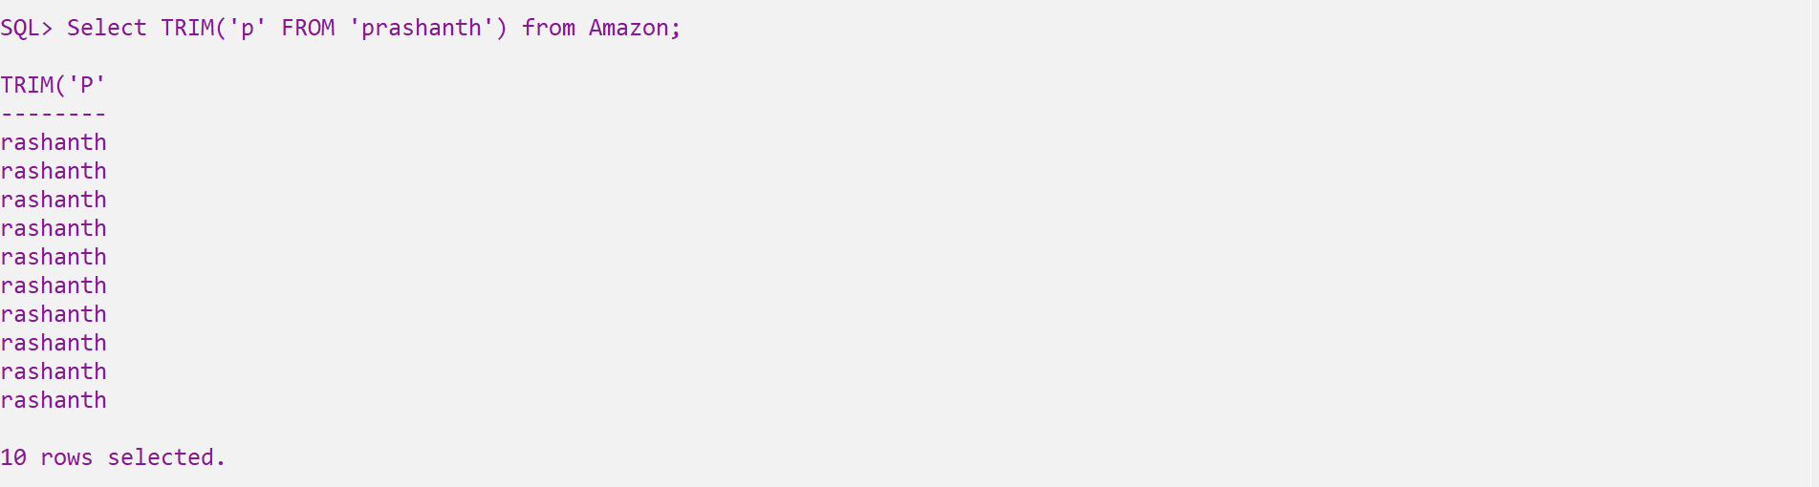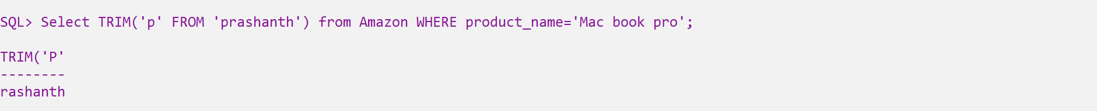

Present purchase_date

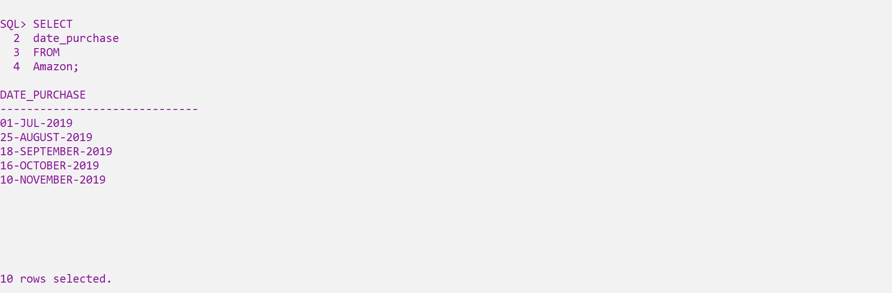

SELECT add_months(<column_name>,3) FROM <table_name>

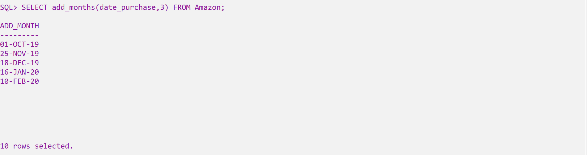

From the present date to date after 3 months

SELECT add_months(<column_name>,-3) FROM <table_name>

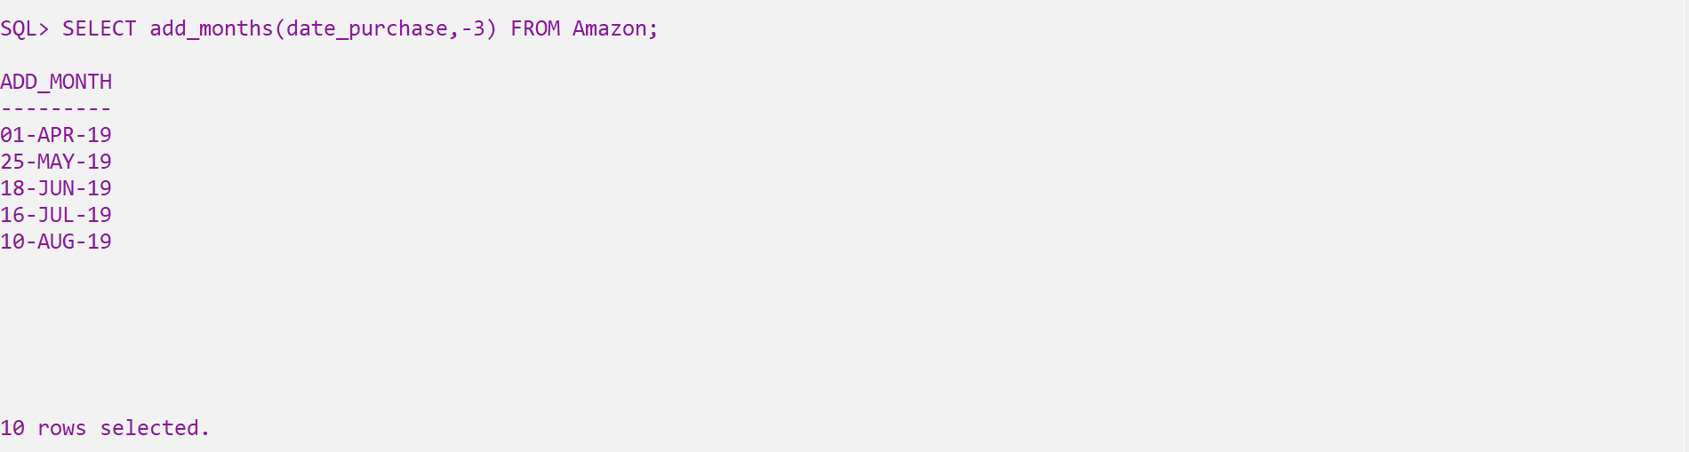

From the present date to date before 3 months

SELECT last_day(<column_name>) FROM <table_name>;

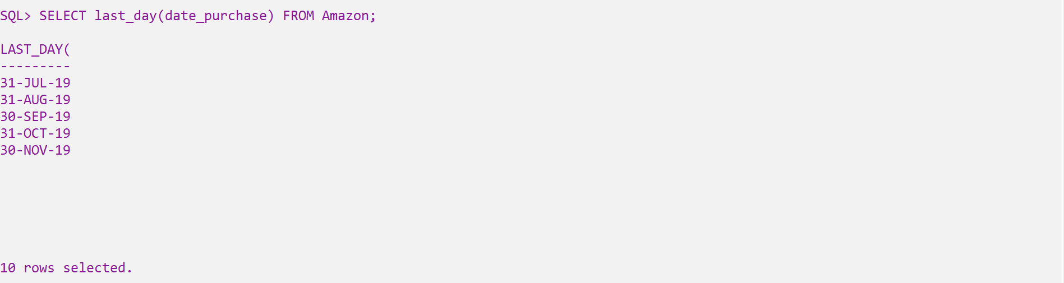

Last day of that particular month

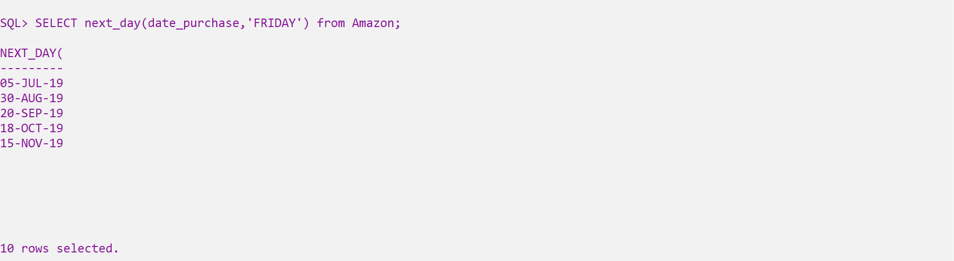

SELECT <column_name>,ceil(<column_name>) from <table_name>

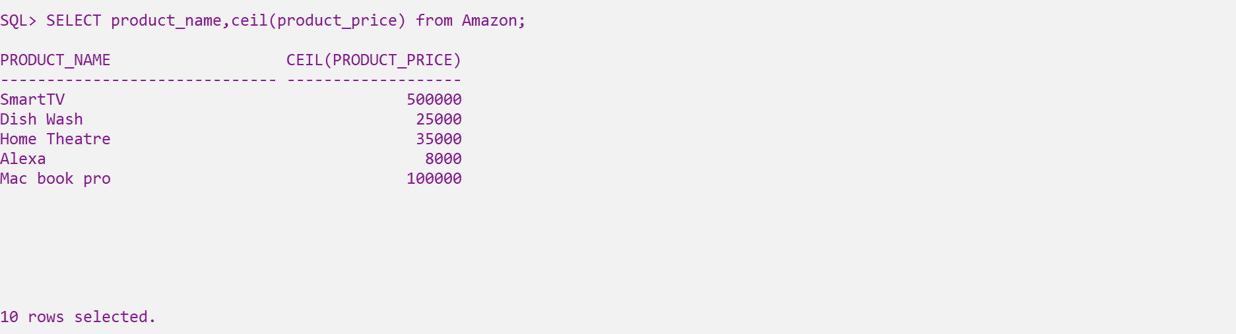

SELECT mod(number1,number2) from dual;  
SELECT power(number1,number2) from dual;

